

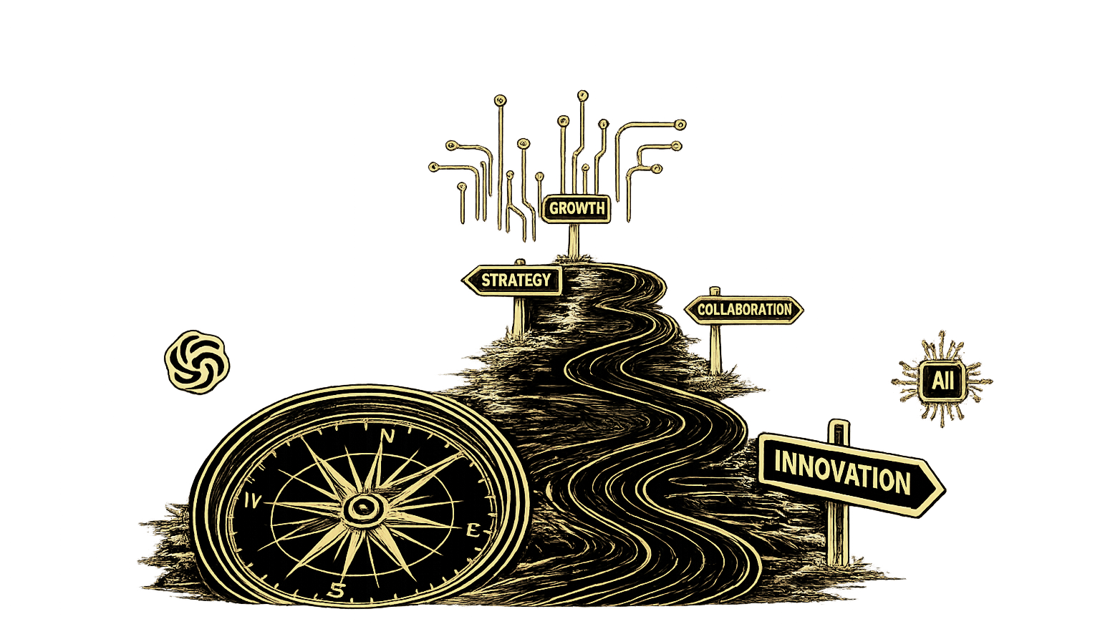

Church Statement on AI

Your Church Statement on AI
This document offers suggested wording to help you create a Church Statement on AI. Please ensure you read “AI Guidelines for Christian Ministry” before attempting this.
This is an optional tool for churches to use to enable them to effectively communicate both at ministry team level and congregation level. It helps to fulfil the ethical principles discussed in our Guidelines, beginning with transparency. Churches are free to edit or adapt ALL text to their local context.
Note the following:
- This is a statement, not a policy. It helps your church take an initial position in a complex and fast-moving area and refine it later.
- Where boilerplate text is provided, the first option is more cautious, and the last option more exploratory.
- Text in angled brackets <> is an instruction to be read and then replaced or deleted.
- To understand Primary versus Secondary use of AI, and Critical versus Non-Critical work, refer to the Guidelines, Section 5.

How to have your church conversation – a suggested approach
Ensure that everyone has read the Guidelines and this Statement prior to meeting. Since there is huge media interest in this topic, expect people to come with opinions.
- Introduce the discussion: it’s very easy to focus on the harms of AI, but you should talk about both harm and good. Point out that you are not trying to decide here if AI is good or bad, you are trying to agree a position, and name areas of ministry where AI could help, areas where AI could harm, and agree guardrails. How you use AI is as important as whether you use AI.
- Open discussion - The following question enables people to surface thoughts and concerns:
Where could AI assist our mission and ministry, and where might its use be unwise?
Allow an hour and encourage people to say what they use AI for, if anything. This can simply be a discussion or, if you prefer, use a flipchart and make 2 columns: 1) If we use AI really well, what good could come? And 2) If we use AI carelessly, what could be damaged?
- Go to Question 2: Ask people to say which of the 3 positions they feel best represents them and their actual use of AI. Some will sit between the options and that’s fine. Use this to find a centre of gravity.
That may be enough for this initial conversation. Don’t rush to complete this. Once you have discussed Question 2, you can come back to the rest later, or one or two people can take the consensus from the discussion and work through the remaining questions themselves.

<Insert Church-Name> Statement on AI
- We the <leadership / ministry team / church members> of < insert Church-Name >,
having <review and select all that apply>
- Discussed this topic among our <leaders / members / ministry team>
- And considered the benefits and costs of using AI
- And reviewed the AI Guidelines for Christian Ministry

We propose the following statement:
- Our overall view on the use of AI in ministry <select one>
- At this stage we consider AI’s implications to be too uncertain. We will not use AI in our ministry, other than the specific areas listed below.
- We believe that AI may be a powerful tool for ministry, but only when used in a way that is consistent with Christian values.
- We will make space for the creative and innovative use of AI. We reject a risk-averse approach and embrace dynamic faith that responds to the Holy Spirit’s leading.
- Our ethical principles
  - Transparency - creating material
<How we will inform people if AI was used in generating content - noting that over-disclosure of every slide or every phrase that is improved, by AI, can create unnecessary anxiety.
In the text below, “ministry” includes all teaching, publications or online content.
Select as many options as apply to you>
- When AI is used as a Primary OR Secondary tool to support the creation of any content in our ministry, eg rephrasing or checking, this will be noted in situ, eg at the end of a PPT presentation or a footnote to a newsletter etc.
Example note: “AI-assisted - reviewed by a leader”.
- When AI is used as a Primary tool for any content in our ministry, this will be noted in situ, eg at the end of a PPT presentation or a footnote to a newsletter etc.
Example note: “Created using AI - reviewed by a leader”.
- We will provide a single, general statement on our <website / Members or PCC meeting minutes / etc> that AI may be used to support our ministry, but we will not usually denote every individual use.
Example statement: “Our church may use AI to assist with content. All AI content is reviewed, and our leaders remain responsible for everything we publish”.

  - Transparency - direct interaction
Will we allow people to interact directly with an AI that represents our church? <Select one>
- We will not use AI to directly engage with individuals (for example, no AI chatbots or “sermon bots” on our website).
- We may use AI tools that interact with individuals, but they will identify themselves clearly as AI, and a named person <insert name/role> will oversee their use.
3.3 Accountability - AI under human authority < Select the box >
- The <Leadership / Ministry Team> accepts responsibility for all uses of AI in this church’s ministry that follow the principles and commitments of this statement.
3.4 Privacy <Select one>
- No personal data (names, contact details etc, or any descriptions of pastoral situations) will be made available to AI.
- No personal data (names, contact details etc) will be made available to AI.
If pastoral situations are input to AI, we will anonymise and generalise them so that no individual can reasonably be identified.
Meetings < Select the box >
- If we use AI to record meetings and create notes or minutes, consent will be sought from participants.
3.5 Human dignity and the common good < Select the box >
- We commit to practising discernment in our use of AI through conversation and regular review: checking for accuracy and bias, noticing where AI may compromise prayerful reflection, or human relationships, staying informed of AI’s impact on the environment, and intentionally stepping back from AI when its use begins to undermine our values.
- Containment - areas of our ministry where AI may be used <This section is optional>
AI will not be used in the following critical areas of ministry:
☑ Safeguarding decisions or case discussions <do not untick>
☑ Detailed pastoral notes or records of confidential conversations <do not untick>
In these critical areas of ministry:
< create your own list eg: writing sermons or talks, writing public prayers or liturgy, writing songs, offering counselling or prayer … etc, then select one of the following positions >
- We will not use AI
- We may use AI but only as a Secondary tool
- We may use AI as a Primary or Secondary tool with appropriate review by our leadership team
In other (non-critical) areas of ministry:
- AI may be used as a Primary or Secondary tool as decided by our leadership team.
- AI tools approved for use in our ministry <Optional>
- We will maintain a list of AI tools approved for use in this church, reviewed at least once a year. < Include your list here.>

- Administering this statement
  - This Statement provides a foundation for how we use AI in ministry. It is not a legal document nor a formal policy. In case of discrepancies, our data protection / GDPR and safeguarding policies take precedence over this Statement.
  - Questions about the use of AI in this church should be addressed to: <name or role>.
  - Review - due to the changing nature of AI, this statement will be reviewed: <select one>
- Every 6 months
- Every 12 months

< Today’s Date >

Statement from the AI Christian Partnership 2026
Statement from Salvation Army UK 2025

